**Question 1**

*Experts (UI/HCI Specialists*) can be involved in the design of user interfaces.

1. Explain how they can help developers to produce better user interfaces.

By making sure they adopted the principles and guidelines related to UI design as shown in the following diagram. Experts can examine the prototype to determine whether it satisfy design guidelines using such as the 8 golden rules or 10 principles of interface design. This set of principles and guidelines will ensure the UI designed are effective, efficient and can keep the user satisfied, the usability goals are achieved.

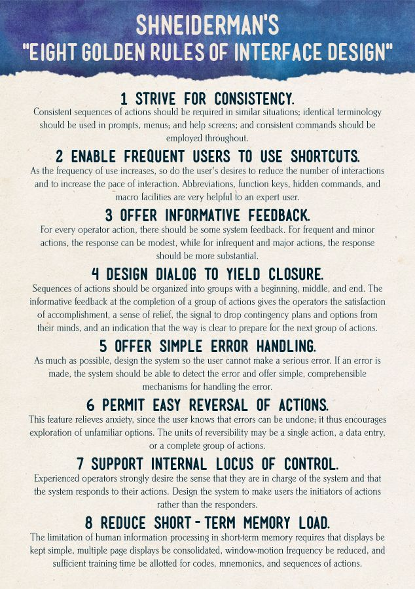

1. Evaluate the advantages and disadvantages of involving experts?

Advantage: Low cost, no need to get user to test the system, faster, cheaper.

* Expert reviews is fast and inexpensive because:
  + it does not require the use of a **well-equipped lab**
  + it does not require the involvement of **users**
* The basic intention is to identify any areas that are likely to cause difficulties
* Can be used at any stage in the development process from a design specification, through storyboards and prototypes, to full implementations

Disadvantage: Not easy to locate expert, multiple experts may give conflicting advice, experts are not end users themselves.

**Question 2**

Many large software development companies have usability laboratories to test their software.

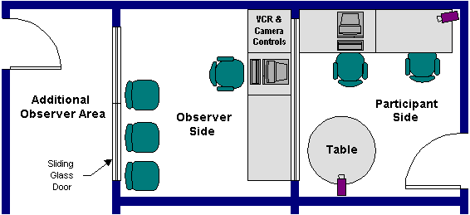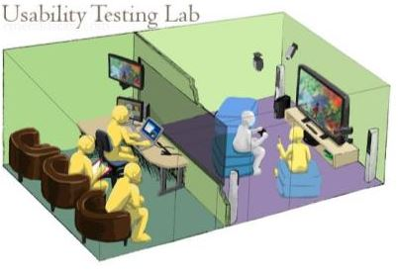

<https://news.microsoft.com/1998/05/19/usability-testing-microsofts-unique-approach/>

<https://www.nngroup.com/articles/usability-labs/>

1. Discuss the pros and cons of testing software in a usability laboratory.

Advantages:

Can identify which tasks are particularly difficult to accomplish, number of errors made, and how long user spend to complete a task, catches problem not found in expert reviews based on the observation from behind.

Disadvantages:

Time consuming and costly, hard to recruit volunteers, environment might be artificial, hard to know what the user thinks.

1. How many tester(s) is/are needed for the first test and subsequent tests. Give reason for each of your answers.

For first test, 1 tester for developers who are familiar with usability testing. If not, then 3 testers. This is to reconfirm other testers’ findings. Subsequent test needs 2 to 4 testers. Any more testers will not be optimal to find out significantly more problems.

**Question 3**

1. Compare and contrast between *field studies* and *usability testing in a usability laboratory.*

Field studies – Watching the users using a system in an actual working environment.



Usability testing – Require the use of formal labs to perform user testing in a controlled and artificial environment, these may not reflect the actual use of the systems.



1. For field studies, what do you think are the right things to do in order to minimise the *Hawthorne/Observer Effect*?

Let them know they are watched not for their performance and that it is okay to make mistakes but its hard to make them belief you.

Studies using hidden observation can help avoid the Hawthorne effect,

1. Fill-in the empty cells for the table below:

|  |  |
| --- | --- |
| **Evaluation and testing** | **Techniques** |
| (1) with users involvement | field studies, usability testing, questionnaire surveys, face to face interviews techniques can be applied here |
| (2) without users involvement | heuristic evaluation by experts, cognitive walkthrough |